

Module Title: Advanced Integrated Computing Devices

Module Code: IS3S687

Module Leader/Tutor: Nathan Thomas/Paul Jarvis

Assessment Title: Internet of Things (IoT) Design Case Study using the Raspberry Pi

Student Name: Dilukshika Sivanathan

Student No: 30073395

Table of Content

Scenario: Smart Home Monitoring System for Energy Efficiency 3

1. Abstract 3

2. Introduction 3

3. Scenario 4

4. Visual Representation 6

5. User Interface 7

6. Benefits of the Smart Home Monitoring System 11

7. Conclusion 12

8. Referencing 13

Table of Figure

Figure 1 Visual Representation Image 6

Figure 2 Home page UI 7

Figure 3 Devices Page UI 8

Figure 4 Living Room Page UI 9

Figure 5 Over view Page UI 10

# Scenario: Smart Home Monitoring System for Energy Efficiency

# Abstract

The IoT-based smart home monitoring system examined in this paper integrates real-time monitoring and control of energy-consuming devices to increase household energy efficiency. Since poor usage of lights, air conditioners, and other equipment frequently results in energy waste, this system attempts to assist homes in lowering their carbon footprint and power expenses. With the help of sensors and smart devices, the system collects and evaluates data on energy use, giving users the knowledge they need to make wise energy-saving choices. Additionally, the system provides mobile access and automatic controls, which make it possible to remotely regulate household energy use. This creative approach to energy management promotes responsible energy behaviors, reduces waste, and improves user comfort and convenience—all of which are in line with sustainability goals.

# Introduction

Home energy use is becoming a bigger problem, particularly as electricity prices rise and people want to live more sustainably. Due to the efficient usage of appliances, HVAC (heating, ventilation, and air conditioning) systems, and lighting, many homes need more energy. It has a more significant environmental impact and is more expensive. An Internet of Things (IoT)-based smart home monitoring system can assist in resolving this issue by enabling homeowners to track and manage their energy consumption in real-time more efficiently.

The purpose of this report is to investigate how IoT-based smart home technologies might lower energy waste and increase house efficiency. We will examine these systems' operation, underlying technology, and advantages in reducing energy consumption. Future advancements in smart home energy management as well as possible obstacles will be discussed in the paper. Ultimately, this case study illustrates how smart home technology may promote sustainability initiatives and reduce energy expenses.

# Scenario

Home energy management is more crucial than ever due to the rising cost of electricity and growing ecological concerns. Energy waste occurs in many homes due to poor use of household appliances, HVAC (heating, ventilation, and air conditioning) systems, and lights (The Renewable Energy Hub. 2024). For instance, appliances utilize electricity when not in use, HVAC systems may operate even when the temperature is pleasant, and lights are frequently left on in vacant rooms. In addition to raising the electricity price, this also damages the environment and increases needless energy use. Finding a way to better control energy use without compromising homeowners' comfort or convenience is challenging.

*IoT-Based Solution for Energy Efficiency*

An Internet of Things (IoT)-based smart home monitoring system is a creative answer to this problem. By automating the operation of many household devices, the system enables homeowners to better monitor and regulate their energy consumption in real time. Motion sensors, for instance, can recognize when a room is empty and immediately switch off lights or modify the HVAC system to conserve energy. Sensors for temperature and humidity ensure HVAC systems are only turned on when necessary, increasing comfort and reducing energy waste. The computer can also be used to monitor usage and turn off equipment when not in use by connecting smart plugs and appliances.

There are many benefits to this IoT-based system. This helps homes lessen their environmental impact while also lowering energy expenditures by ensuring that energy is used more efficiently. The technology ensures that energy is utilized only when necessary and removes human mistakes by automating energy management. Users may make well-informed decisions and adopt energy-saving practices thanks to the system's real-time data and insight into energy usage. This smart home system provides a good balance between sustainability, convenience, and energy efficiency. In order to control energy use, the system would gather data from sensors (such as light, motion, and temperature sensors) and operate appliances like smart plugs. Additionally, the homeowner would receive alerts or recommendations for energy-saving measures via a dashboard or mobile app (Kim, J., Byun, J., Jeong, D., Choi, M., Kang, B. and Park, S. 2015).

Input Devices

*DHT20 Temperature and Humidity Sensor:*

Monitors the environment of the house by taking measurements of the humidity and temperature.

*Light Sensor:*

Determines whether the space is bright or dark by measuring the ambient light levels, which aids in the lighting's automatic adjustment.  
*Motion Sensor:*

It may determine whether people are in the area, enabling more sophisticated energy-saving measures (such as shutting off appliances while nobody is around).

Output Devices

*Relay Module:*

It serves as a control switch that, depending on the energy-saving logic of the system, turns lights or appliances on or off. For instance, it can mimic shutting off lights, air conditioning, or heating to save energy.  
*LCD Display:*

Allows users to easily monitor and control the system's operations by displaying real-time data such as temperature, humidity, light levels, and energy usage status.

# Visual Representation

# C:\Users\Dilu\OneDrive - University of South Wales\USW\Advanced Intergreated computer devices\Assignments\CW1M\Visual Representation.png

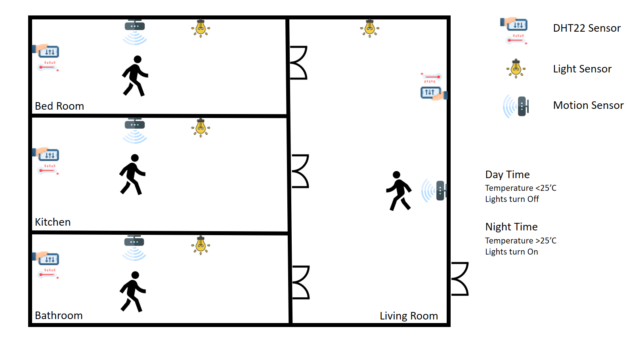

Figure 1 Visual Representation Image

During the day, the lights are turned off to save energy if the temperature falls below 25 degrees Celsius. The light is activated at night when the temperature rises above 25°C. In addition, the system uses motion sensors to detect human presence, ensuring that lights are turned on only in occupied rooms, thereby reducing wasteful energy use (Kim, J., Byun, J., Jeong, D., Choi, M., Kang, B. and Park, S. 2015).

# User Interface

The screenshots below show a user interface design strategy that highlights clarity and simplicity, which are crucial for a smart home control app:

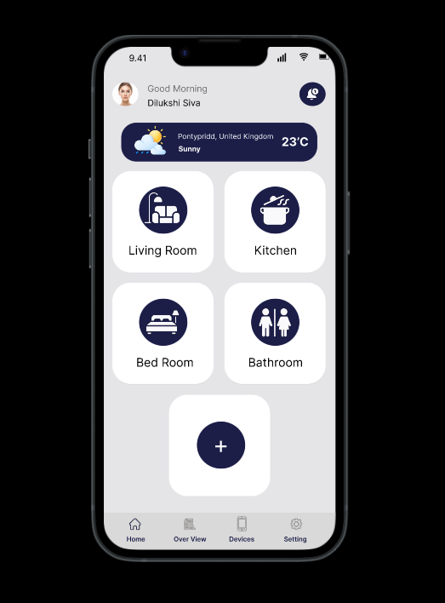

Figure 2 Home page UI

This picture shows how many parts the house is made of. Apart from that there is also the facility to create additional parts.

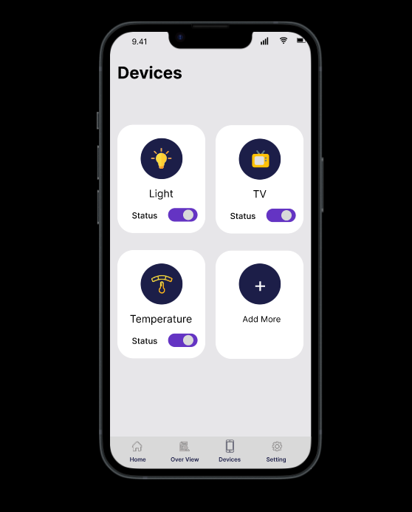

Figure 3 Devices Page UI

In this picture, devices are built according to how many devices are going to use energy efficiency in the smart home, and the facilities are built for on and off button for show the status.

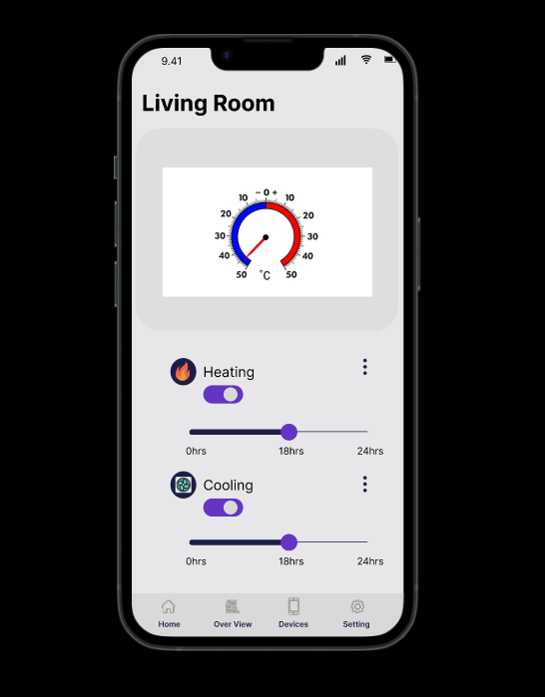

Figure 4 Living Room Page UI

In this picture, we will see the energy-efficient device transmitted there. For example, if we want a heater, we can turn it on/off by checking the room's temperature. Apart from that, we can easily control how long we need the heater to work.

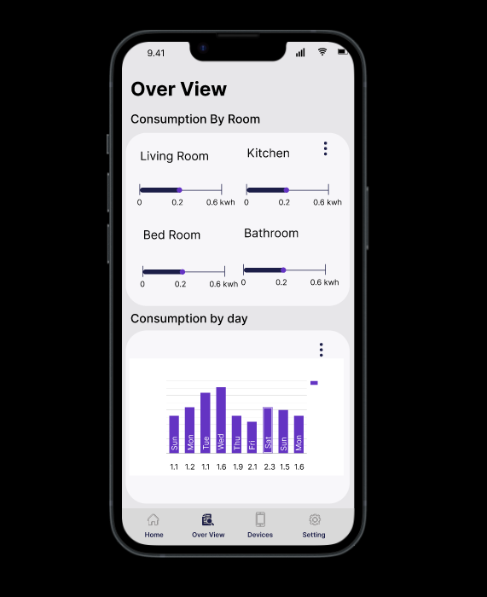

Figure 5 Over view Page UI

In this, we can see how much energy efficiency is consumed by room and day.

# Benefits of the Smart Home Monitoring System

Many benefits are available to homeowners who use a smart home monitoring system, which makes it simpler to control energy use more efficiently, conveniently, and sustainably (El-Azab, R. 2021).

* **Lower Energy Bills:** By automatically controlling energy use, the device assists homeowners in lowering their electricity expenses. It guarantees that energy is only utilized when required, resulting in cost savings without sacrificing comfort.
* **Reduced Environmental Impact:** Households can drastically cut their carbon footprint by reducing energy waste. This promotes responsible energy use and has a beneficial environmental impact, which is in line with global sustainability goals.
* **Enhanced Convenience:** Homeowners can benefit from a more straightforward and efficient method of energy management with IoT-based automatic controls. The system handles all of the manual adjustments for appliances, HVAC systems, and lights. Additionally, the mobile app is quite convenient because it allows customers to monitor and adjust their energy usage from any location.
* **Enlightened Decision-Making:** The technology offers data and insights on energy usage trends in real time. By determining which gadgets consume the most energy, homeowners can modify their settings or behaviors to increase efficiency. This gives them the confidence to more consciously embrace long-term energy-saving measures.
* **Increased Comfort:** By modifying the temperature, humidity, and lighting levels in accordance with user preferences, the system creates the perfect home environment. Because the system keeps the living area comfortable and well-controlled, homeowners may save energy without compromising comfort.

# Conclusion

IoT-powered smart home monitoring systems offer a creative way to address the problems associated with household energy use. Homeowners can effortlessly monitor and manage their energy consumption by combining sensors, smart devices, and an intuitive mobile app. This automated system efficiently controls the use of appliances, HVAC, and lights, cutting waste, expenses, and the carbon footprint of the home.  
  
These systems should only become better with continued developments in IoT and smart home technology, providing even more individualized and effective energy management choices down the road. All things considered, a smart home monitoring system is an important step towards a more economical, practical, and sustainable way of life.

# Referencing

The Renewable Energy Hub. (2024). *How to Make Your Smart Home as Energy-Efficient as Possible.* Available at:<https://www.renewableenergyhub.co.uk/blog/how-to-make-your-smart-home-as-energy-efficient-as-possible> (Accessed 15 Oct. 2024).

El-Azab, R. (2021). *Smart homes: potentials and challenges.* *Clean Energy*, Available at: <https://academic.oup.com/ce/article/5/2/302/6294582> (Accessed 15 Oct. 2024).

Kim, J., Byun, J., Jeong, D., Choi, M., Kang, B. and Park, S. (2015). *An IoT-Based Home Energy Management System over Dynamic Home Area Networks. International Journal of Distributed Sensor Networks*, Available at: <https://journals.sagepub.com/doi/10.1155/2015/828023> (Accessed 15 Oct. 2024).

‌

‌

‌

‌